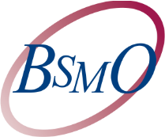
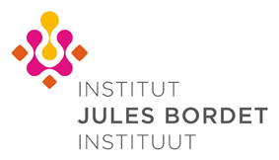

Breast Cancer Debate of the Year – Friday January 24, 2020
Best of SABCS® 2019 – Saturday January 25, 2020
Location: THE HOTEL (Boulevard de Waterloo 38 1000 Brussels) (“Grand Ballroom”, 1st Floor)
☐ Mr./Mrs ☐ Professor ☐ Doctor  First Name: Cliquez ici pour entrer du texte.  Hospital: Cliquez ici pour entrer du texte.  City : Cliquez ici pour entrer du texte. | Numéro INAMI : Cliquez ici pour entrer du texte.  Family Name: Cliquez ici pour entrer du texte.  Department : Cliquez ici pour entrer du texte.  Email: Cliquez ici pour entrer du texte.

I will attend the Breast Cancer Debate of the Year on Friday 24th January from 7.00 to 10.15 PM  I will attend the Best of SABCS® on Saturday 25th January from 9.00 to 12.45 AM  I will attend the lunch on Saturday 25th January from 12.45 to 2.00 PM  I will need accommodation (rooms being limited please do note that accommodation is not offered to participants living in Brussels neither to participants that will only join the meeting on Saturday) | YES ☐ NO☐  YES ☐ NO☐  YES ☐ NO☐  YES ☐ NO☐

Please return your response by January 15th to P. Adam (+32 (0) 2 541 32 06) by email: martine.piccart@bordet.be
For all information please contact P. Adam : +32 (0) 2 541 32 06 or martine.piccart@bordet.be
Institut Jules Bordet, Medicine Oncology Department 121 Boulevard de Waterloo 1000 Brussels

